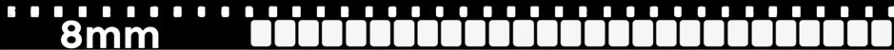
8mm film is a home movie format and is the most common format found in the Tennessee Archive of Moving Image and Sound collections. Released in 1932 by Kodak, 8mm was more affordable than currently available motion picture stock such as 35mm, which was reserved for feature films, and 16mm, which was used for home release or for lower budget, artistic films.
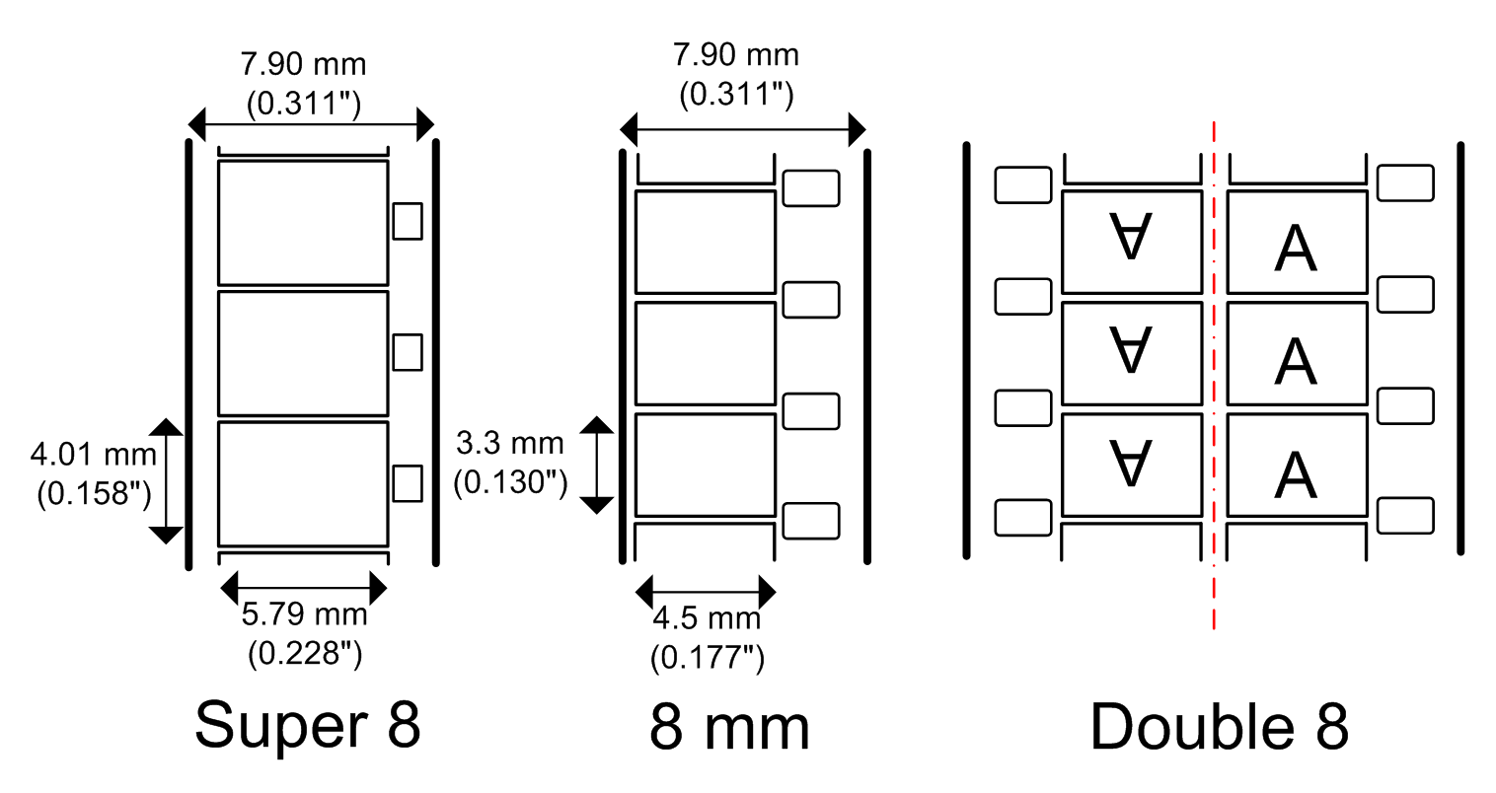
8mm film is 16mm that has been slit into two parts. It was typically sold in rolls of 50’ for home movie camera use and spliced (connected by tape or cement) by either the processing lab or by the owner of the film. Most of our reels are 200-400’.
The stock is a reversal film, meaning that there is no negative produced – the film would produce a positive image when processed. This means that there is only one copy of the typical home movie. Keep this in mind as you handle and process these unique artifacts!
8mm
8mm
16mmm
Not all 8mm films are home movies—that is, movies shot by the owner of the film. Many 8mm films are releases of feature films for home use. Companies such as Castle Films would edit down feature-length films into 8mm condensed stories that are essentially highlight reels of the plot. Unlike the typical reversal film home movie, these 8mm features are not unique artifacts. Negatives and 35mm prints likely exist elsewhere. These films are identifiable by the existence of credits, intertitles (frames with dialog or scene settings), and the lack of splices.
HEAD ↑
Parts of 8mm Film

- Head
Perforations (“perfs”)
TAIL ↓
  - Beginning of film
- Tail
  - End of film
- Perforation (“perfs”)
  - Holes in film that engage with the projector to move film forward
  - Distance between perfs may shrink due to decay (called “shrinkage”)
△ ■
Edge Code
- Splices
  - Two pieces of film connected by tape or cement (glue)
  - Weak points of film, may come apart and need repaired
- Edge
  - Sides of film
  - Edge Codes
    - Symbols for year, color process, manufacturer, etc.
    - For Kodak, combinations of +, ⬤, △, or ■ indicate the year film was processed

